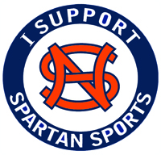
NSCHS Spartans Athletic Booster Club, Inc.
PO Box 566541
Atlanta, GA 31156
North Springs Charter High School
7447 Roswell Rd.
Atlanta, GA 30328

Dear Donor, Date

On behalf of the Spartans Athletic Booster Club, Inc. and the staff of North Springs Charter High School, we would like to sincerely thank you for your generous donation of $Amount towards the sports program at NSCHS.

Explain why you need the donation and how it helps the sports program. For example, discuss how the money donated may be used.

The Spartan Athletic Booster Club, Inc. is exempt from federal taxes under section 501(c)(3) of the Internal Revenue Code. Donations to the Spartas Athletic Booster Club, Inc. are tax deductible to the extent allowed by law.

Once again, thank you for your donation. It is greatly appreciated.

Sincerely,

You name
Your title

